**RELATIONAL DATABASE PROJECT (SEQUEL)**

**INTRODUCTION**Access to clean water and proper sanitation is a fundamental human right, yet millions of people in Africa still lack these basic necessities. This project focuses on analyzing data related to water access, sanitation infrastructure, and community health across African communities. By examining key metrics such as water availability, functionality of water sources, and incidence of waterborne diseases, the project aims to uncover patterns and challenges that hinder progress. The ultimate goal is to provide actionable, data-driven recommendations to governments and stakeholders to improve water and sanitation conditions, thereby enhancing the quality of life for affected communities.

**OBJECTIVES**The primary objectives of this project include the following;

1. Analyze water availability and population distribution.
2. Assess the functionality of water sources.
3. Evaluate sanitation infrastructure and maintenance costs.
4. Identify communities with high rates of waterborne diseases.
5. Evaluate support programs from the government and NGOs.
6. Propose recommendations for governments and stakeholders.

**METHODOLOGY**

The dataset provided (**Water_Supply_Sanitation_Africa**) was utilized for the purpose of this project as follows;

--Create Database

CREATE DATABASE Water_Supply_Sanitation_Africa

**1** --Calculate the average water availability (liters per capita per day) for each country

SELECT Country, ROUND (AVG (Water_Availability_liters_per_capita_per_day),2) AS Average_Water_Availability

FROM [Water_Supply_Sanitation_Africa].[dbo].[Water_Supply_Sanitation_Africa]

GROUP BY Country

ORDER BY Average_Water_Availability DESC;

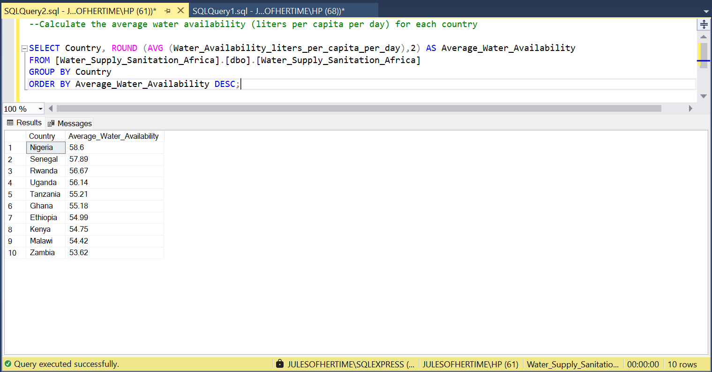

**2** --Retrieve details of communities where at least one water point is non-functional.

SELECT Community_Name AS Communities, Country, Region, Population

FROM Water_Supply_Sanitation_Africa

WHERE Number_of_Non_Functional_Water_Points >0;

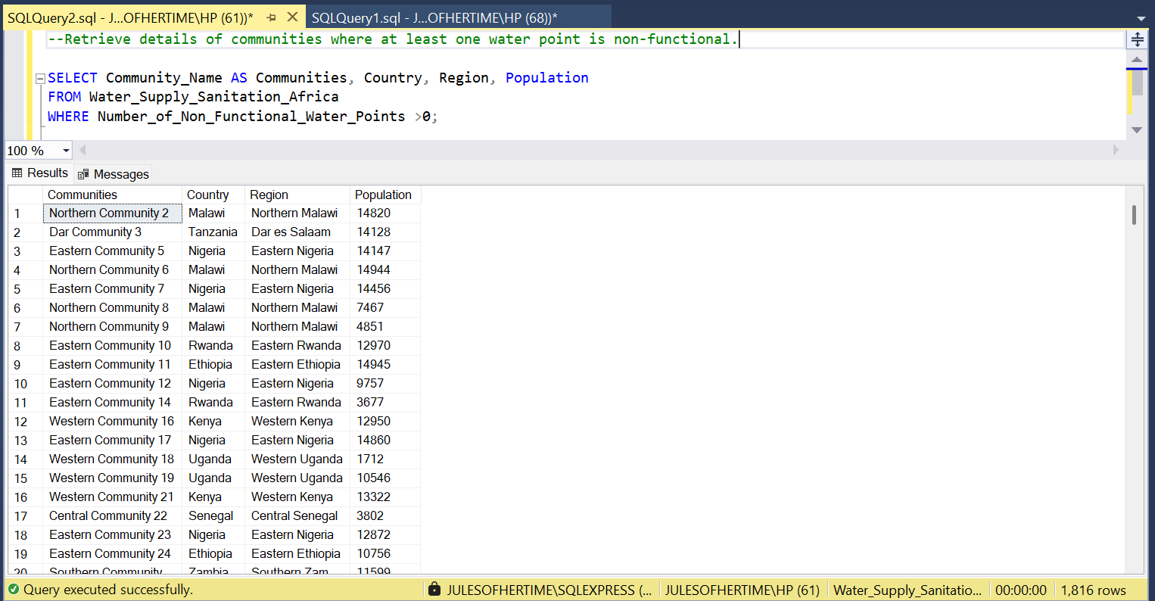

**3** --Top five communities with the highest annual sanitation maintenance costs.

SELECT TOP 5 Community_Name, Country, Annual_Maintenance_Cost_USD

FROM Water_Supply_Sanitation_Africa

ORDER BY Annual_Maintenance_Cost_USD DESC;

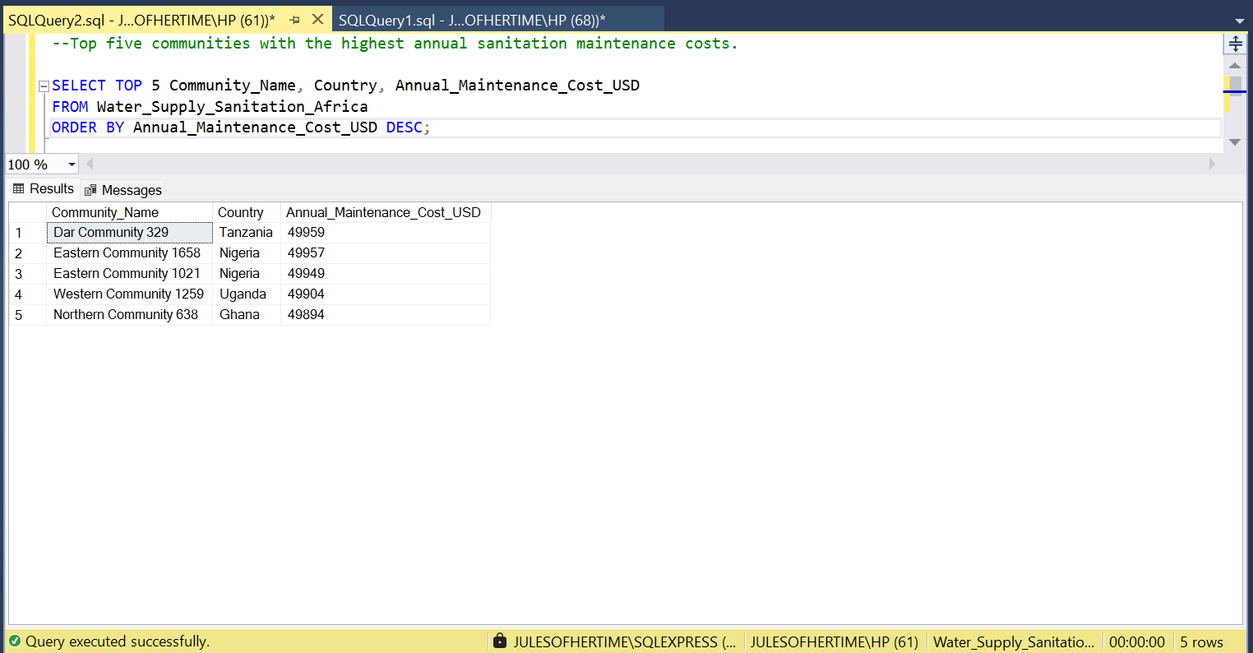

4 --Total number of functional and non-functional water points per country

SELECT Country, SUM (Number_of_Functional_Water_Points) AS Total_Functional_Water_Points,

SUM (Number_of_Non_Functional_Water_Points) AS Total_Non_Functional_Water_Points

FROM Water_Supply_Sanitation_Africa

GROUP BY Country;

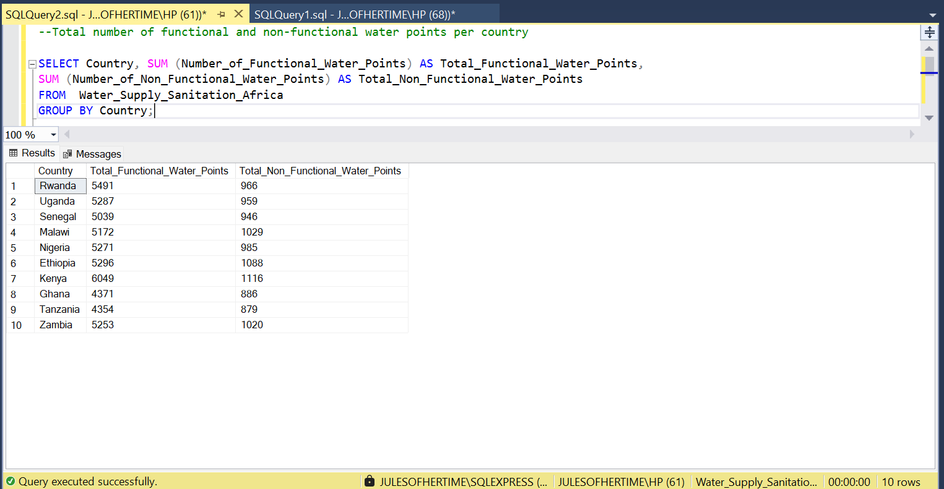

5 --Identify communities with a high incidence of waterborne diseases (>20%)

SELECT Community_Name, Country

FROM Water_Supply_Sanitation_Africa

WHERE Waterborne_Diseases_Incidence_Rate >20;

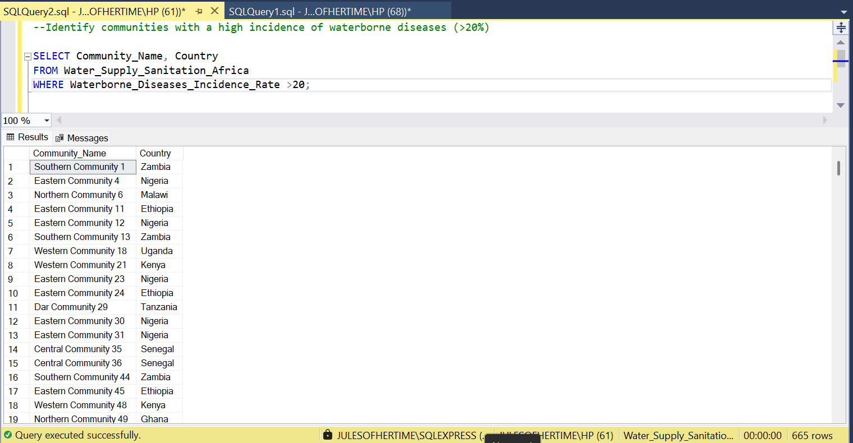

6 --Find the average distance to the water source per region

SELECT Region, ROUND (AVG (Average_Distance_to_Water_Source_km),2) AS Average_Distance_To_Water_Source

FROM Water_Supply_Sanitation_Africa

GROUP BY Region

ORDER BY Average_Distance_To_Water_Source;

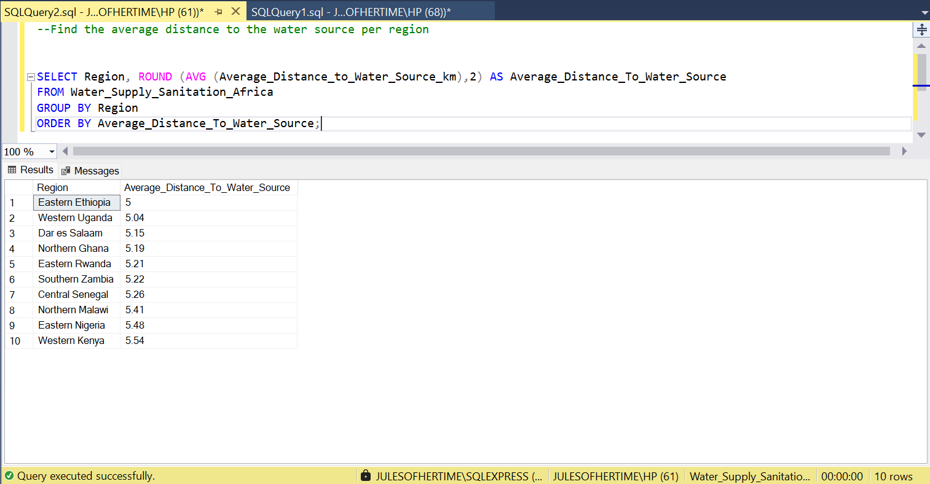

7 --List the communities that receive both government and NGO support

SELECT Community_Name, Country, Region

FROM Water_Supply_Sanitation_Africa

WHERE Government_Support = '1' AND NGO_Support = '1';

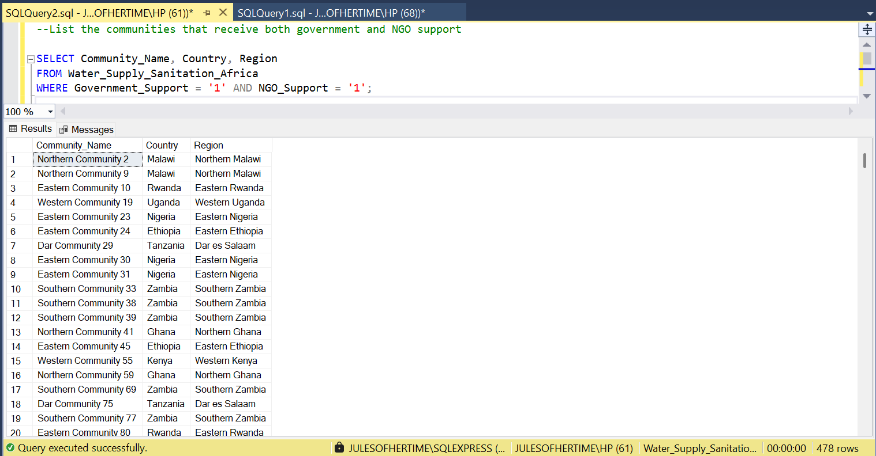

8 --Identify the community with the highest population per country

SELECT Community_Name,Country, Population

FROM Water_Supply_Sanitation_Africa AS TABLE1

WHERE Population = (SELECT MAX (Population)

FROM Water_Supply_Sanitation_Africa AS TABLE2

WHERE TABLE2.Country = TABLE1.Country)

ORDER BY Population DESC;

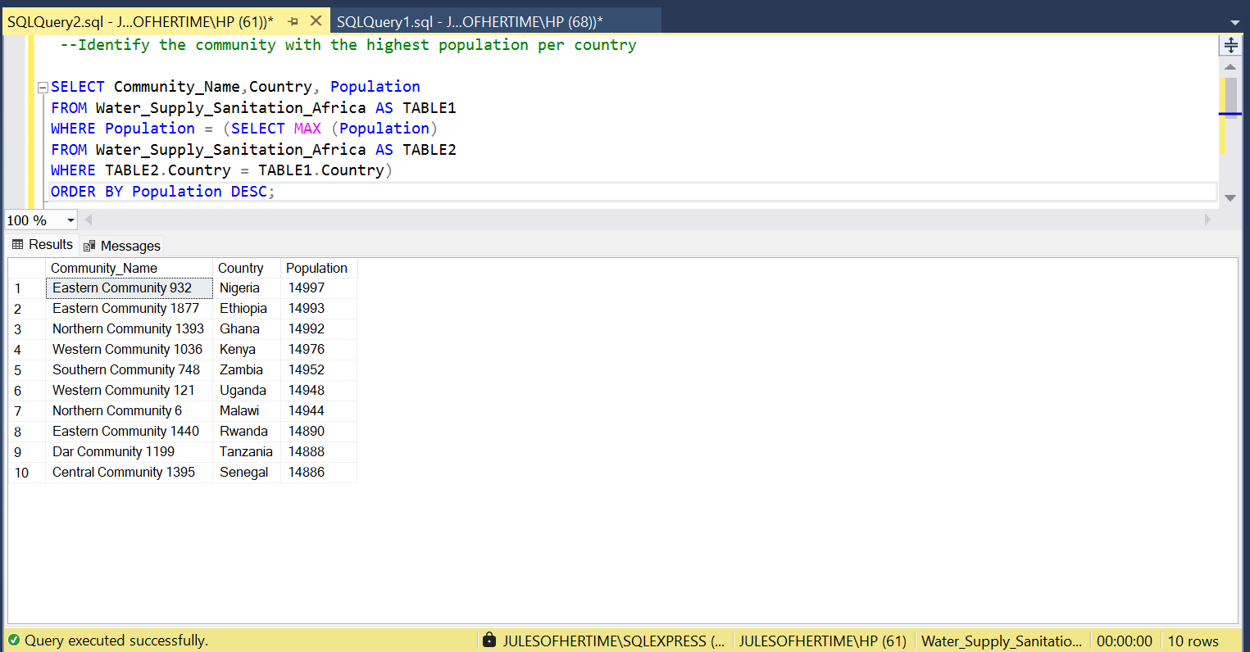

**RECOMMENDATIONS**Based on the analysis, several recommendations are proposed to improve water access and sanitation in Africa. First, governments and NGOs should prioritize repairing non-functional water points in communities with low water availability. Second, targeted interventions should focus on areas with high rates of waterborne diseases, including improved sanitation infrastructure and public health campaigns. Third, optimizing maintenance costs for sanitation facilities can ensure long-term sustainability. Finally, community engagement programs should be implemented to address local needs and improve satisfaction with water and sanitation services.

**CONCLUSION**In conclusion, this project highlights the critical role of data analysis in addressing water and sanitation challenges in Africa. By identifying key issues such as non-functional water points, high sanitation costs, and communities with high disease rates, the project provides a foundation for targeted interventions. The recommendations outlined aim to guide governments and stakeholders in making informed decisions to improve water access and sanitation. Moving forward, further analysis and collaboration with local communities will be essential to achieving sustainable progress in this vital area.